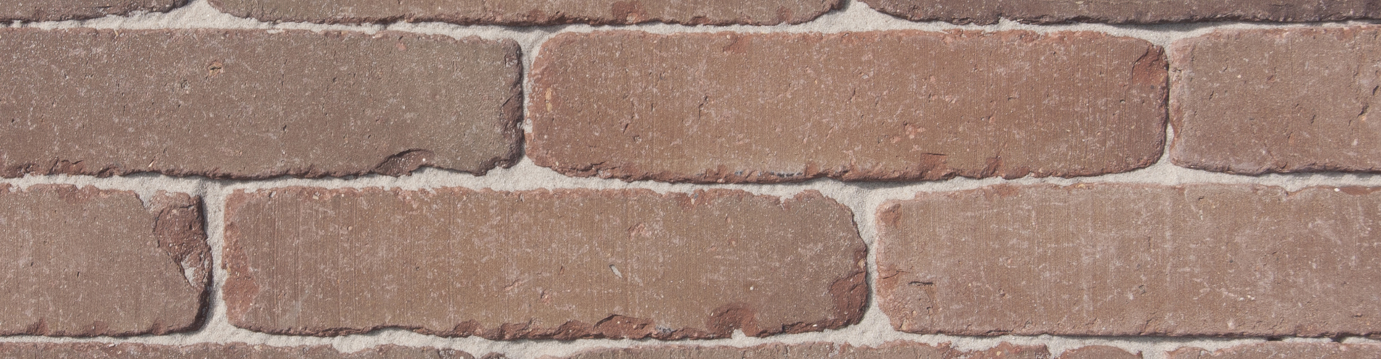

COLOUR
Red-brown.

Product description
The bricks are formed individually in the unsanded mould to a solid mass, pressed from clay of alluvial origin from an area located in the Scheldt basin and fired in a tunnel oven at a temperature of approximately 1180°C. On the narrow side the bricks have an unsanded surface structure. The shape is slightly irregular. Finally the bricks are processed until they have acquired a weathered
shape, due to which the paver surface leaves a rustic, aged impression.

TECHNICAL CHARACTERISTICS
The paving is laid in fired clay bricks of Belgian origin, quality class A, carrying the Benor mark, the CE mark and UKCA mark.
CE label according to EN 1344 : 2013 / AC : 2015
Manufacturing dimensions (L x W x H) | *217x52x70 mm
Quantity / m² with a traditional joint | ca. 85

PHYSICAL AND MECHANICAL PROPERTIES ACCORDING TO EN 1344: 2013 / AC: 2015
Aspect | Class | Mean | Individual
Water absorption NBN EN771 | W3 | Max 3% | Max 4%
Transverse breaking load | T4 | Min 80 N/mm | Min 64 N/mm
Abrasion resistance | A3 | Max 450 mm³ | Max 500 mm³
Frost resistance | FP100 | freeze/thaw resistant | freeze/thaw resistant
Wet skid resistance | U3 | >55
Acid resistance | C | < 7%
Size tolerance* | NPD | NPD | NPD

Productshot
