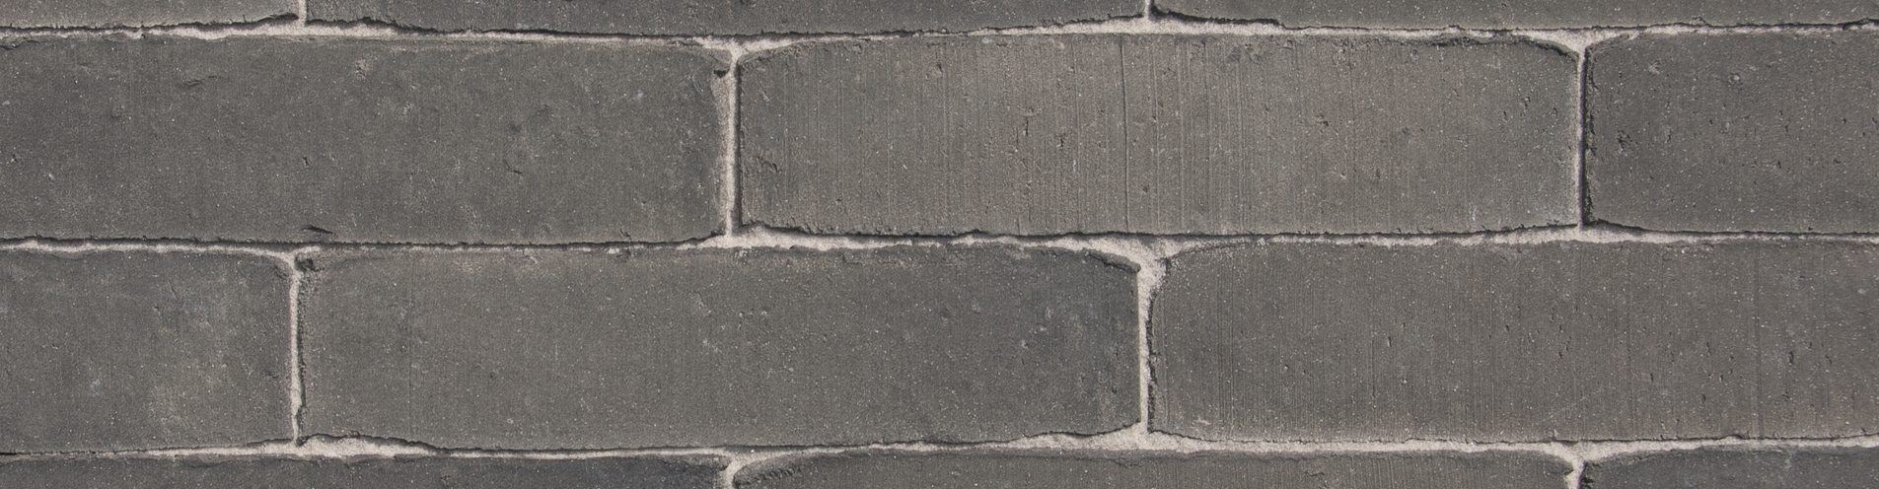

COLOUR
Dark grey

Product description
The bricks are formed individually in the unsanded mould to a solid mass, pressed from clay of alluvial origin from an area located in the Scheldt basin and fired in a tunnel oven at a temperature of approximately 1180°C. On the narrow side the bricks have an unsanded surface structure. The brick is fired a second time with complete reduction.

TECHNICAL CHARACTERISTICS
The paving is laid in fired clay bricks of Belgian origin, quality class A, carrying the Benor mark, the CE mark and UKCA mark.
CE label according to EN 1344 : 2013 / AC : 2015
Manufacturing dimensions (L x W x H) | *210x50x103 mm | on demand for projects > 2000 m²
Quantity / m² with a traditional joint | ca. 91
Manufacturing dimensions (L x W x H) | *210x67x103 mm | on demand for projects > 2000 m²
Quantity / m² with a traditional joint | ca. 68

PHYSICAL AND MECHANICAL PROPERTIES ACCORDING TO EN 1344: 2013 / AC: 2015
Aspect | Class | Mean | Individual
Water absorption NBN EN771 | Class W3 | max 3% | max 4%
Transverse breaking load NBN EN1344 | Class T4 | min 80 N/mm | min 64 N/mm
Abrasion resistance NBN EN1344 | Class A3 | max 450 mm³ | max 500 mm³
Frost resistance NBN EN1344 | Class FP100 | freeze/thaw resistant | freeze/thaw resistant
Size tolerance NBN EN1344 | Class R1 | ± 0,4 √d | 0,6 √d (range)
Wet skid resistance NBN EN1344 | Class U3 | >55
Acid resistance NBN EN1344 | Klasse C | < 7% | < 7%

Productshot
