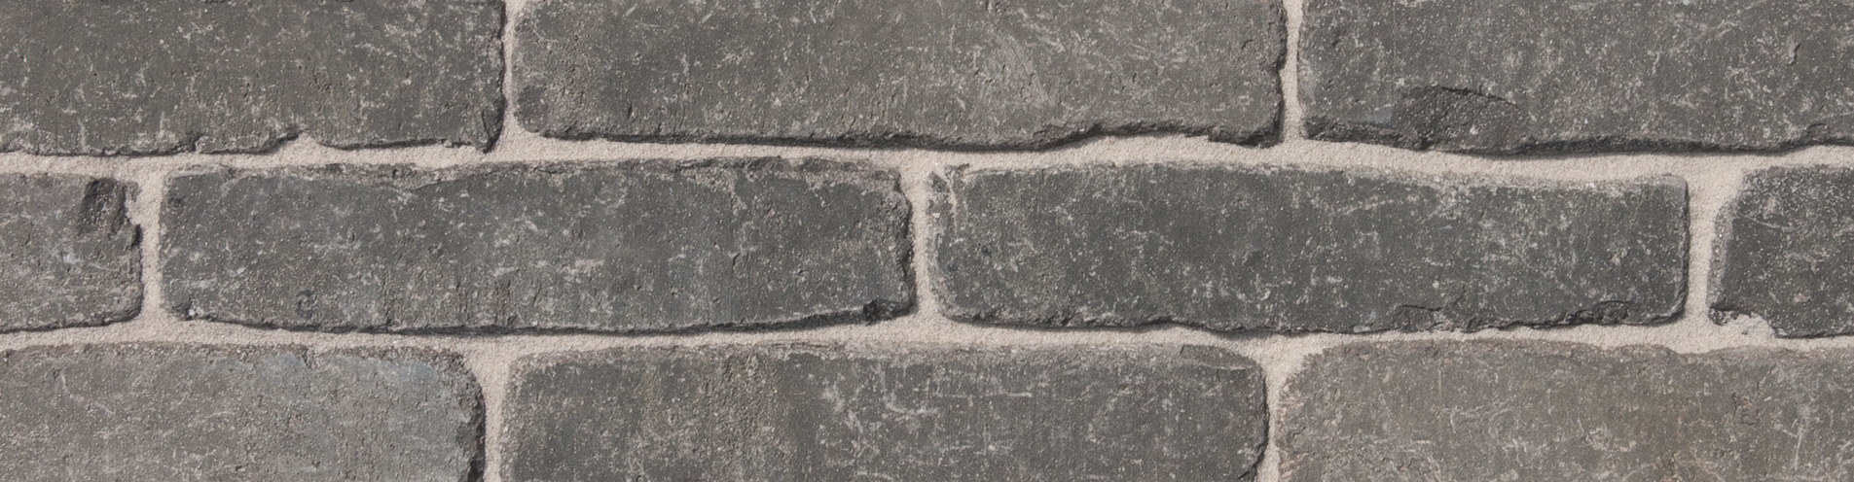

COLOUR
Dark grey with nuances.

Product description
The bricks are formed individually in the unsanded mould to a solid mass, pressed from clay of alluvial origin from an area located in the Scheldt basin and fired in a tunnel oven at a temperature of approximately 1180°C. On the narrow side the bricks have an unsanded surface structure. The shape is slightly irregular. Finally the bricks are processed until they have acquired a weathered
shape, due to which the paver surface leaves a rustic, aged impression. The brick is fired a second time with complete reduction.

TECHNICAL CHARACTERISTICS
The pavers are delivered with the following characteristics, in accordance with the CE and UKCA mark:
CE label according to EN 1344 : 2013 / AC : 2015
Manufacturing dimensions (L x W x H) | *188x45x63 mm
Quantity / m² with a traditional joint | ca. 111

PHYSICAL AND MECHANICAL PROPERTIES ACCORDING TO EN 1344: 2013 / AC: 2015
Aspect | Class | Mean | Individual
Water absorption NBN EN771 | Class W2 | max.5% | max.6%
Transverse breaking load NBN EN1344 | Class T4 | min 80 N/mm | min 64 N/mm
Abrasion resistance NBN EN1344 | Class A2 (+) | max.600 mm³ | max.800 mm³
Frost resistance NBN EN1344 | Class FP100 | freeze/thaw resistant | freeze/thaw resistant
Size tolerance NBN EN1344 | Class R1 | ± 0,4 √d | 0,6 √d (range)
Wet skid resistance NBN EN1344 | Class U3 | >55
Acid resistance NBN EN1344 | Class C | < 7%

Productshot
